PROJECT SYNOPSIS

1. Project Title
“College ERP System (Authentication and Authorization module)”

2. Introduction
The project is a College ERP System developed in the Education domain to manage and automate academic and administrative activities. It integrates modules like authentication, admissions, examination and result, student records, notifications and feedback, and placements into one platform. The system reduces manual work and improves data management. It also provides secure access through authentication and authorization for different users.

3. Problem Statement
Many colleges still manage data and processes manually or through separate systems, which leads to inefficiency, data duplication, and lack of proper co-ordination. There is no single centralized platform to handle admissions, exams, student records, and other activities smoothly. Also, the system lacks a secure login mechanism to verify user identity. There is no proper role-based access control, which can allow unauthorized users to view or modify sensitive data. Therefore, a secure authentication and authorization module is required to ensure safe and controlled access to the ERP system.

4. Objectives
• To design and develop a system for managing and integrating all college activities in one platform
• To improve efficiency, accuracy, and accessibility of academic and administrative data
• To ensure secure user authentication and role-based authorization across the system

5. Proposed System
This system is College ERP that integrates all academic and administrative activities into a single digital platform. It will allow users like students, faculty, and administrators to access and manage data based on their roles. The system will automate processes such as admissions, examinations, student records, and notifications. The Authentication and Authorization module will ensure secure login and control access to different features. This will improve efficiency, data security, and overall management of the college.

6. Scope of the Project
The system can be used in colleges to manage academic and administrative activities in one place.
It will be used by students, faculty, and staff for tasks like admissions, exams, and records.
The ERP system can be accessed through a web-based platform within the institution.
It ensures centralized data management and secure access for all users.

7. Technology Stack (Proposed)
- Frontend: ReactJS
- Backend: FastAPI
- Database: PostgreSQL
- Tools: Antigravity ,Postman Collections (API testing), Ngrok (local server tunneling), Trello Board (project management)

8. Entity-Relationship Diagram (ERD)
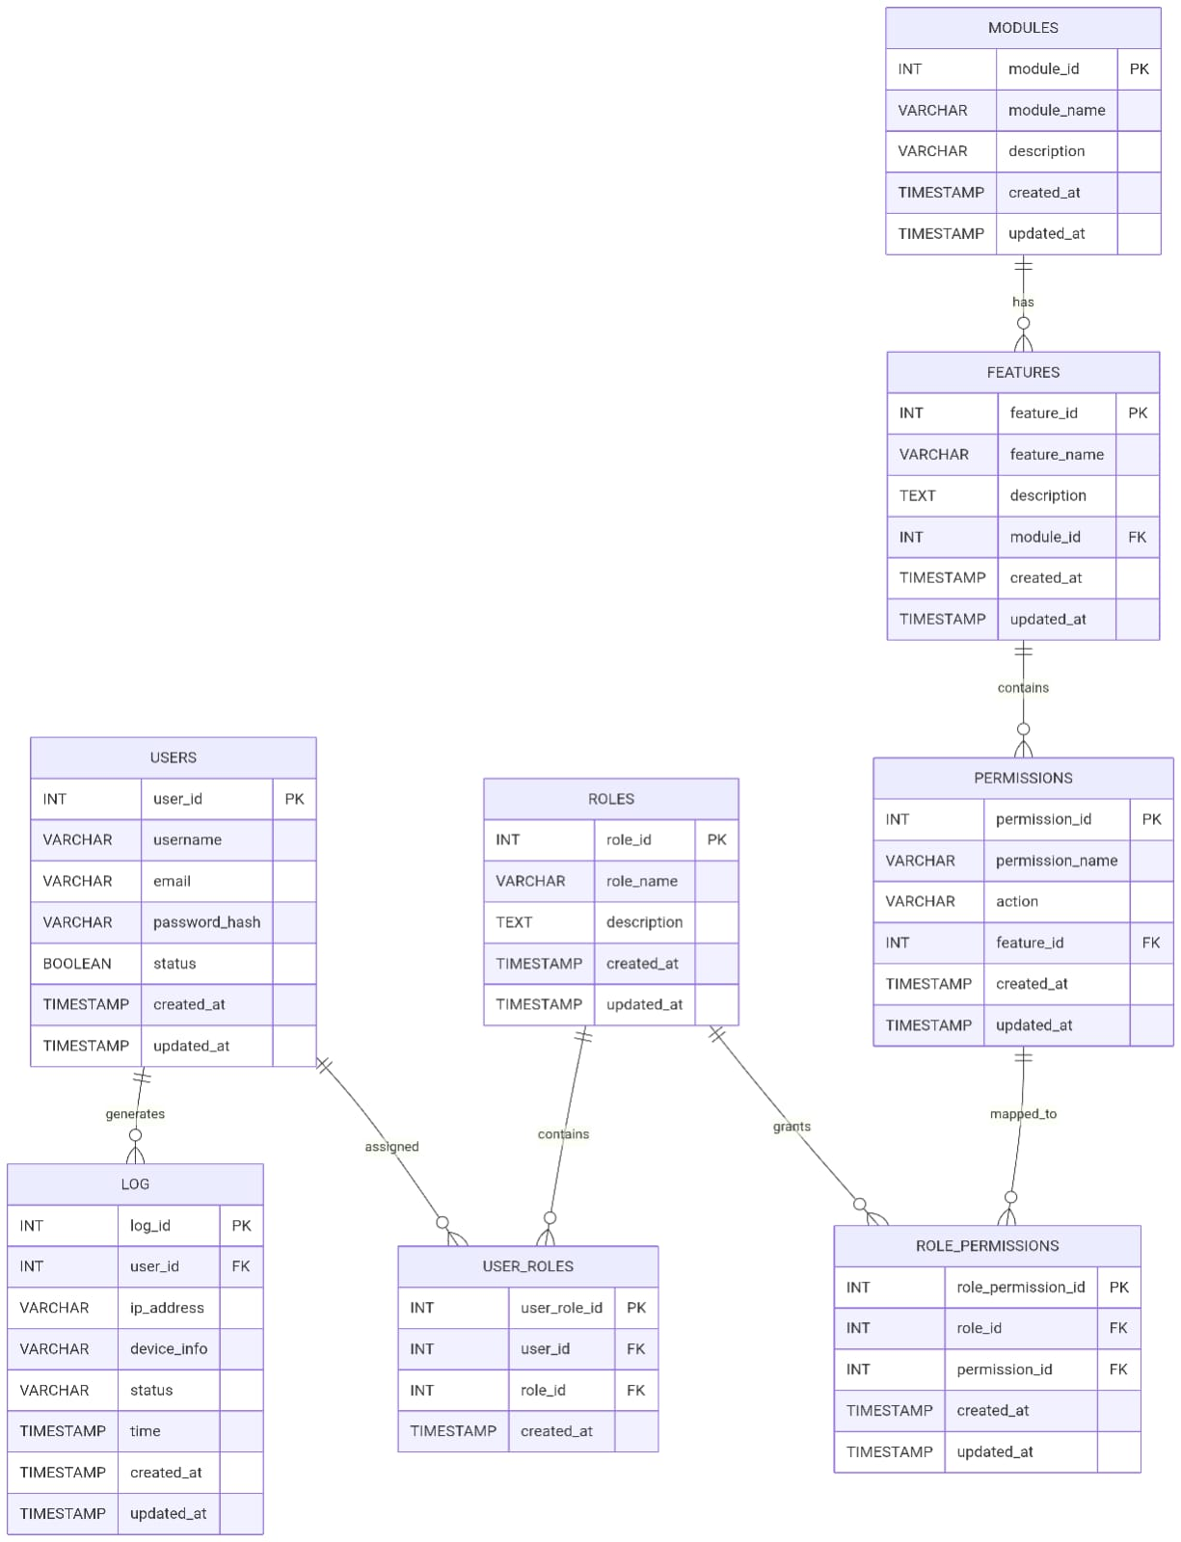

9. Expected Outcome
The system will centralize and simplify college operations, reducing manual work and errors. It will provide secure, role-based access to users through proper authentication and authorization. Overall, it will improve efficiency, data security, and transparency. The system will streamline college processes by bringing all operations into a single platform. It will ensure better coordination between departments and easy access to information. Secure login and role-based control will protect data and improve overall system reliability.

10. Conclusion
The College ERP System is important for efficiently managing academic and administrative activities in one place. It improves productivity, data accuracy, and communication within the institution. The inclusion of secure authentication and authorization ensures safe and reliable system usage

11. Student Details
- Name: Swaraj Bhagat
- Class: SY MSC CS
- Seat Number:2359
- Signature:

12. Guide Approval
- Guide Name:
  - Mrs. Rekha Joshi
  - Mr. Rajesh Darak

- Signature:___________
- Date: ______________

